THE ROLES OF ACROSPORT
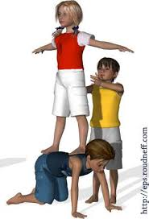
Base: He stand as a base, use her body for support.

Top: He climbs in the highest position of the pyramids and he perform the most difficult acrobatics.

Helper: He helps the other player to complete the pyramids, or he helps to keep players safe.

Exercise 1:
Put this word in the right box.
power – taller - good musculature – good attention - bigger - thin – stronger – lighter – agility - resistance – careful – rapidity – athletic – sure – courageous
BASE

TOP

HELPER

Exercise 2:
What’s your physics characteristics? What’s your possible role?
_________________________________________________________________________________________________________________________________________________________________________________________________________________________________________________________________________________________________________________________________________________________

